GUIDED CAPSTONE PROJECT REPORT

1.0 HYPOTHESIS:
Big Mountain Resort's recent investment has resulted in a $1,540,000 increase in seasonal operating costs. To improve the company’s bottom line, the resort plans to develop a more efficient ticketing system and aims to reduce expenses by 20% within the next fiscal year.

2.0 ABSTRACT:
Big Mountain Resort is a ski resort that offers breathtaking views of Glacier National Park and Flathead National Forest, with access to 105 trails. The ski resort is in Montana, with annual visitors of about 350,000 people. The company’s investment in an additional chair lift will provide a more comfortable skiing experience by dispersing the skiers more evenly across the mountain, which could positively impact operating costs. Management has assigned a team to develop data-driven strategies aimed at increasing revenue and improving market profitability this year.

3.0 DESIGN & IMPLEMENTATION:
The ski resort data was used in four major steps of the project: Data Wrangling, Exploratory Data Analysis, Pre-Processing & Training, and finally modelling the data. Under the data wrangling step, I cleaned and transformed the data into an analysis-ready format. In the second step, feature engineering was performed by merging state summary features into the ski resort data and visualizing high-dimensional data using PCA. In the preprocessing & training step, I trained the data with machine learning models, linear regression, and random forest, and cross-validated. Finally, I used the model to gain insight into what Big Mountain's ideal ticket price could be, and how that might change under various scenarios.

3.0.1 Data Wrangling:
I meticulously cleaned and prepared the ski resort dataset for in-depth analysis. The dataset contained 330 rows and 27 columns, each featuring various attributes. Upon reviewing the data, I discovered that several columns had missing values. Approximately 14% of the rows in the dataset were missing price information. During my review of the price columns, I noticed that some resorts were missing both weekday and weekend ticket prices. I decided to keep only the rows that included weekend prices (AdultWeekend), as these had fewer missing values compared to weekday prices. After removing the rows with missing or incorrect values, the dataset was reduced to 277 rows and 25 columns. I saved the cleaned ski data and state summary files separately to prevent overwriting the original data.

1.1 Figure below shows the relationship between weekday and weekend ticket prices.
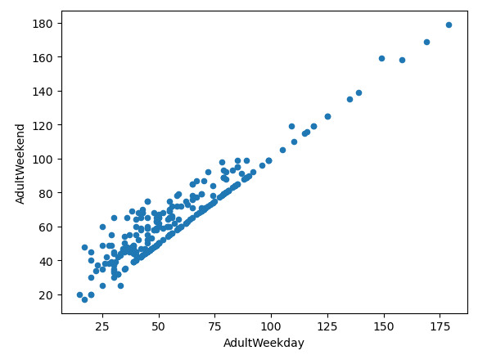

3.0.2 Exploratory Data Analysis:
In this Exploratory Data Analysis, I examined both numerical and categorical features within the dataset. I noticed variations in ski ticket prices related to resort characteristics rather than state-specific patterns. The Principle Component Analysis was used on the key factors influencing prices, including vertical drop, the number of fastQuad lifts, available runs, and total chairlifts. This is done by scaling the data, fitting the PCA transformation to learn the transformation from the data, and applying the transformation to the data to create the derived features. In summary, I chose AdultWeekend as the target variable for modelling and will ensure that all states are treated equally while also including important ratios that reflect state-level differences. I also produced a feature engineering heatmap and scatterplots of numeric features against the ticket price.

1.2 The figures below show the scatterplots of numeric features against the ticket price
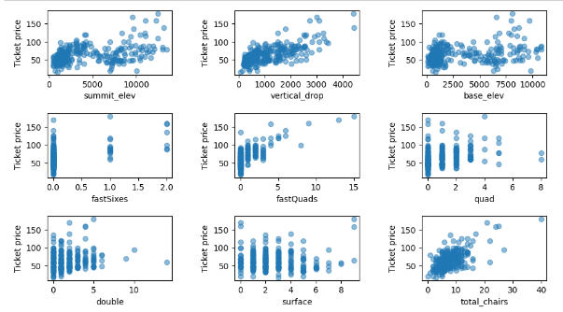

1.3 Feature correlation heatmap
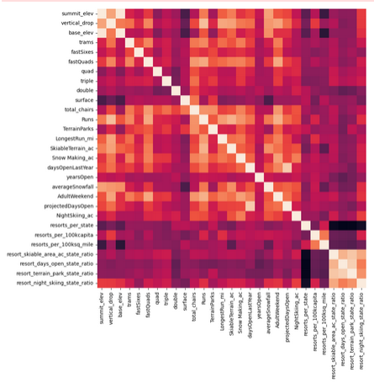

3.0.3 Pre-Processing & Training:
Under this exercise, I began by using sklearn to build a machine learning model, starting with the simplest approach that utilizes the mean value as a predictor. I initially employed a 70/30 train/test split to divide the data into a training set and a testing set. To assess how effectively the mean acts as a predictor, I used the training sets, X_train and y_train, and compared them with sklearn’s DummyRegressor. The Metrics module offers various methods to evaluate how closely one set of values aligns with another or how well it explains the actual values. Additionally, I utilized sklearn's pipeline feature to combine imputation, scaling, and model training into a single step. Ultimately, I evaluated performance using cross-validation with the Random Forest model, which showed lower absolute error and less variability.

1.4 Figure below illustrate best random forest regressor feature importances.
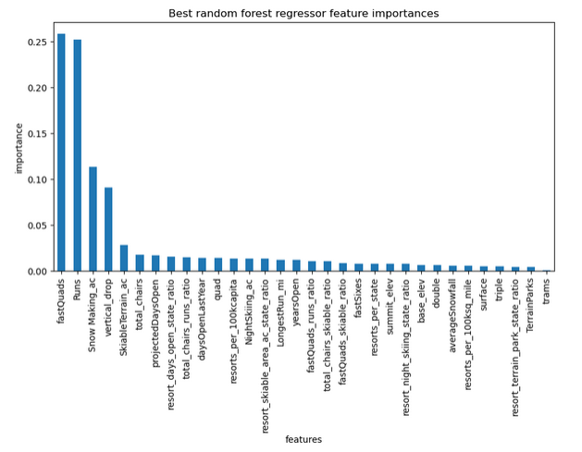

3.0.5 Modeling:
Under this stage, I began analyzing the ski resort ticket price model to estimate suitable ticket prices for Big Mountain while examining how various resort parameters affect them. Four identified options based on modelling scenarios were developed, thus close ten (10) least-used runs, add a new run, add snowmaking coverage and, extend longest ski run. Both prediction models show similar results, but the random forest model ranks the longest run feature lower than the linear model.

1.5 Figure below shows where Big Mountain sits overall amongst all resorts for price and for just other resorts in Montana.
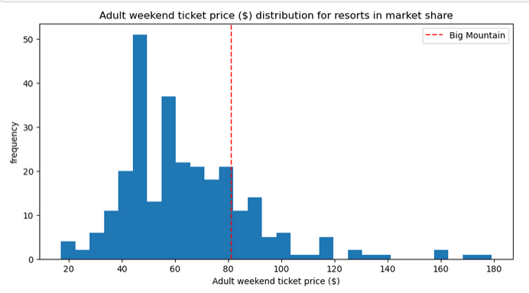

4.0 CONCLUSION & FUTURE WORK:
I was unable to conduct a thorough analysis on how to reduce operational costs due to the lack of available data, which was a significant limitation. To gain insights into Big Mountain Resort's potential pricing capabilities, I used our ski resort ticket pricing model. Additionally, I investigated how changes in various resort parameters could impact this pricing. This model serves as a valuable tool for business executives, allowing them to examine different scenarios by adjusting parameters and assessing potential outcomes for improved results.

